**SANKALCHAND PATEL COLLEGE OF ENGINEERING, VISNAGAR**

**A PROJECT REPORT ON**

|  |  |  |  |
| --- | --- | --- | --- |
| LOAN MANAGEMENT | | |  |
|  |  |  |  |
| |  | | --- | |  |   SYSTEM | | |  |

**SANKALCHAND PATEL COLLEGE OF ENGINEERING, VISNAGAR**

**A PROJECT REPORT ON**

LOAN MANAGEMENT SYSTEM

**Prepared by: -**

**PATEL DHRUV VISHNUBHAI (206310307006)**

**PATEL AYUSH RAJESHBHAI (206310307028)**

**PATEL JEEL VIRABHAI (206310307038)**

**PATEL SHIVAM NILESHBHAI (206310307027)**

**Guided by:**

**MS. P R SHARMA**

**K D POLYTECHNIC, PATAN**

(Dept. of Technical Education, Govt. of Gujarat)

OPP. T. B. Hospital, North Gujarat Uni. Road, Patan - 384265

###### Certificate

This is to certify that the project report entitled ***LOAN MANAGEMENT SYSTEM*** being submitted by PATEL DHRUV V. (206310307006), PATEL AYUSH R. (206310307028), PATEL JEEL V. (206310307038), PATEL SHIVAM N. (206310307027), in fulfillment for the award of the 6th semester in Diploma in Computer Engineering to the Gujarat Technological University is a record of bona fide work carried out by her under my guidance and supervision.

Head of Department Guided by: -

Computer Engineering **Ms. P R Sharma**

**Acknowledgement**

**We have taken efforts in this project. However, it would not have been possible without the kind support and help of many individuals and the organization. We would like to extend our sincere thanks to all of them.**

**We are highly indebted to Ms P R Sharma for his guidance and constant supervision as well as for providing necessary information regarding the project & also for his support in completing the project to this extent.**

**We would like to express our gratitude towards the parents & member of K D Polytechnic, Patan, for their kind co-operation and encouragement which help us in completion of this project.**

**We would like to express our special gratitude and thanks to our Head of the Department Mr R. M. Shaikh sir for giving us such attention and time.**

**Our thanks and appreciations also go to colleagues in developing the project and people who have willingly helped us out with their abilities.**

**Dhruv V. Patel - 206310307006**

**Ayush R. Patel - 206310307028**

**Jeel V. Patel - 206310307038**

**Shivam N. Patel – 206310307027**

###### ABSTRACT

The Loan management system is important and helps to ensure success or failure of any credit institution. Mortgage loan problems have always been a key note on the risk of loan loss. The scope of this project is to provide good communication between the customer and help center. The current system can be a user-friendly system, which does not store data in the proper security and can easily track information and contains the operation of fast-recovery information, such as customer data, all loan details and includes many documents. The system can make daily operations more efficient and provide faster response. Including adding, editing, retrieving customer information, maintaining and issuing new loans, change the loan rate. The scope of this project is to use the loan in a very smart way. The project includes a system analysis and style for obtaining a loan details process, settlement process, and approving the payment process. This project is designed to hit many issues such as data shortage, data inaccuracy, time, etc.

Keywords: loan detail, loan application, report, e-mail

TABLE OF CONTENTS

1. **Introduction**

1.1 Characteristics of Existing system……01

1.2 Overview of Proposed System with

Advantage…………………………….…02

1.3 Scope ……………………………………02

1.4 Process Model …………………...….....03

**2.**  **System Requirements Specification**

2.1 User Characteristics……….………….. 05

2.2 Functional Requirement………………..06

2.3 Non-Functional Requirement……….…09

**3. System analysis modeling-user based**

3.1 Feasibility Study of the New

System…………………………………..11

3.2 User-Based Modeling………………….12

3.2.1 Use Case Diagrams……………...12

**4. System Analysis and Design - Data-based**

4.1 Data Modeling………………………….13

4.1.1 Data Dictionary …………………...13

4.1.2 E-R Diagram……………………….18

4.2 Behavioral Modeling………………….19

4.2.1 Data Flow Diagram……………...19

4.2.1.1 Context Level Diagram…..…19

4.2.1.2 DFD - Level 1………………..20

4.2.1.3 DFD - Level 2………………..20

TABLE OF CONTENTS

**5. System Design – UML**

5.1 Sequence Diagram…………………....22

5.2 Activity Diagram………………………..23

**6. System Interface Design**

6.1 Input-Output Forms Design…………...24

6.2 Graphical User Interface

Design…………………………………..26

**7. Coding Module**

7.1 Login Modules…………..………………28

7.1 Loan Application Modules……..………43

**8. Testing**

8.1.1 Test 1………….………………………56

8.1.2 Test 2………….………………………56

8.1.3 Test 3…………….……………………57

8.1.4 Test 4………….………………………58

**9. Conclusion and Future Scope**

9.1 Conclusion………………………………60

9.2 Future Scope……………………………60

**10. Reference**

10.1 Reference………………………….….61

10.2 Bibliography……………………….…..61

**FIGURE INDEX**

**Sr Name Page**

1.1 Process Model………………………………03

3.1 Use Case Diagram (user side)………….…12

3.2 Use Case Diagram (Admin Side)..…..…….13

4.1 E-R Diagram…………………………………18

4.2 Context Level Diagram..……………………19

4.3 DFD Level 1….………………………………20

4.4 DFD Level 2….………………………………21

5.1 Sequence Diagram.…………………………22

5.2 Activity Diagram…..…………………………23

6.1 Login Form.……………..……………………24

6.2 Payment Form.………………………………24

6.3 Registration Form.……..……………………25

6.4 Loan Application Form...……………………25

6.5 Home Page Customer side ……………..…26

6.6 Home Page Admin side………..…...………26

6.7 Contact Us Page…..………..….....…..…….27

6.8 EMI Calculator Page.…..……...……………27

**TABLE INDEX**

**Sr Name Page**

4.1.1 User_list Table………….…………………14

4.1.2 Loan_application Table..……………...….15

4.1.3 Document Table………………………..…16

4.1.4 Loan_type Table………………………..…16

4.1.5 Payments Table.………………………..…17

4.1.6 loan_plan Table.………………………..…17

# 1. introduction

**1.1 CHARACTERISTICS OF EXISTING SYSTEM**

First of all, Today existing system like some big bank and finance companies loan process is too much time consuming and tricky and rejection rate is too much high compare then your system also customers satisfaction rate is low. Document verification process is complex. Payment and EMI process in not working proper and some customers face payment delay problem. today, existing system misuse your document and some system sell customers details and document for getting money.

* Using manual system in computing amount of money in issuing report and outstanding balance are time-consuming.
* Report and Outstanding balance may be inaccurate and unreliable due to the manual system.
* Difficulty in finding the customer’s files and ir takes a long time to search the details of loan since all data are recorded in files on shelves, not in the computer memory.
* Some work processes are overlapped which causes work duplication.

**1.2 OVERVIEW OF PROPOSED SYSTEM WITH ADVANTAGE**

In this proposed system, we have designed a web page for applying loan and the users can also get the exact information in seconds by searching the types of loan in the “search view”.

This web application will also provide the Contact details of our help center for the communication.

***Advantages:***

* ***Saves time of user.***
* ***It allows users to modify their personal information for edit profile.***
* ***It keeps track of customer service details.***
* ***Fast and accurate.***
* ***Provide better service to the customer.***
* ***It provides a search type of loan option and also Filtering loan interest rate.***

**1.3 SCOPE (LIST OF MODULES AND THEIR FUNCTIONS)**

* Their web application has the following modules:

1. Admin
2. Customer
3. Visitor

* Modules with their functions:

1. Admin
   * Analysis of users.
   * Remove junk profiles and data.
   * Manage Loan details
   * Verify EMI Loan
   * Database management.
2. Customer

* Registration
* Login/Logout
* Edit profile
* Forgot/Reset Password
* **Pay & Search EMI Records**
* **Apply Loan**
* **EMI Calculator**
* **View Loan Details**
* **Enquiry**

1. **Visitor**

* **View Loan Plan**
* **View Loan Details**
* **View EMI details**
* **EMI Calculator**
* **Enquiry**

**1.4 PROCESS MODEL**

In this project we have used iterative waterfall model. The diagram is shown in below:

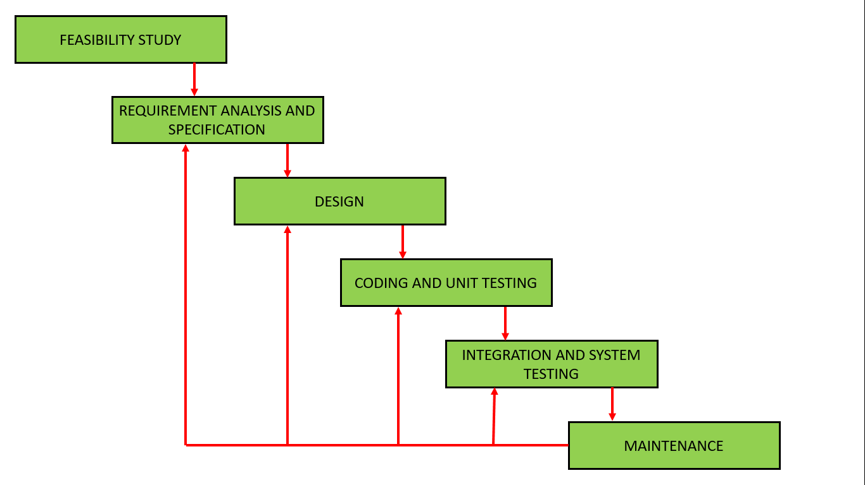

**Figure 1.1: Iterative waterfall Model**

**The advantages of the iterative model are as follow,**

* some working functionality can be developed quickly and early in the life cycle.
* Results are obtained early and periodically.
* Parallel development can be planned.
* Less costly to change the scope/requirements.
* Testing and debugging during smaller iteration are easy.
* Easier to manage risk – High risk part is done first.

**The disadvantages of the iterative model are as follow,**

* More resource may be required.
* More management attention is required.
* Although cost of change is lesser, but it is not very suitable for changing requirement.
* System architecture or design issues may arise because not all requirements are gathered in the beginning of the entire life cycle.
* Defining increments may require definition of the complete system.
* Management complexity is more.

**The reason that we choose this model is,**

* It is simple and easy to understand and use.
* Each phase has well defined input and output.
* It divides complex tasks into smaller ones.
* The major advantage is that is has back tacking.
* It is highly cost-effective to change the plan or requirements in the model.
* In this model, less time is consumed on documenting and the team can spend more time on development and designing.

# ****2. system requirement specification****

**2.1 USER CHARACTERISTICS**

User characteristics show the different types of users with specific role:

* **User**
* There are main two users : -

1. Admin
2. Customer
3. Visitor

* **Admin:-**
* Admin can login the system with his user name and password.
* Admin can change password.
* He can manage loan type and interest rate in the system.
* Admin can manage loan application sent by customer using the system.
* He can maintain information & details to the customer such as customers name, address, contact no, bank account no, email id, salary reports, etc. Only Admin can manage customer record.
* He can manage loan details such as loan no, loan type, Loan Amount, loan interest rate, issue date, etc. for the customer.
* He can calculate and manage EMI details.
* **Customer :-**
* The customer – seeking the loan and information related loans.
* They can view an interest rate and the loan type in the system.
* They can apply loan application using the system to get loan.
* User can register with the basic information like User name, Mobile no, email etc.
* User can login the system with his username and Password.
* They can view their information & details such as customer name, address, contact no, bank account no, pan card no, email id, etc.
* They can view loan details such as loan no, loan type, Loan Amount, loan interest rate, issue date, etc.
* They can view their EMI details.
* They can view the details of given payment of an EMI detail.
* **Visitor :-**
* The visitor view information related loans.
* They can view an interest rate and the loan type in the system.
* They can view loan details such as loan type, Loan Amount, loan interest rate, etc.
* They can view their EMI details.

**2.2 FUNCTIONAL REQUIREMENTS**

Functional requirements define what a software product must do: its features and functions.

The different modules and their functionalities are described below :-

1. Admin Module

The admin is the person who will manage the system. Admin will manage the database operation.

* **Functionalities :-**
  1. **Overall analysis of users**
* **This functionality describes that admin has access for analysis of the user interaction.**
* **Admin can manage the entire database system.**
  1. **Remove Junk User Account**
* **This functionality describes that admin has access to remove unused accounts.**
* **Admin can remove the account from the database which left by the user for a long time.**
  1. **Overall Database Management**
* **This functionality describes that admin manage the entire database system.**
  1. **Overall Manage Loan Details**
* **This functionality describes that admin will maintain the loan detail records of every user on a regular basis.**
  1. **Verify EMI Loan**
* **This functionality describes that they verify the loan due of users whether that is paid or on due.**

**6. Loan Request**

* **This Functionality describes that admin can view loan application that is sent by users.**

**2. User Module**

**The user a person who can apply for loan.**

* **Functionalities :-**

1. **Register**

* **The user has to first register themselves for accessing the website.**
* **In the register page the user has to enter their Full name, email, password, mobile number, confirm password & other things.**

1. **Login/Logout**

* **The user has to login after successfully registered.**
* **In the login page the user has to enter user id or email and password.**
* **The user can logout if they want.**

1. **Forgot/Reset Password**

* **The user can reset/change their password in case if the user forgot it.**

1. **Edit Profile**

* **The user changes their account/profile details.**

1. **Apply Loan**

* **The user can apply for loan online application with supporting documents.**

1. **EMI Calculator**

* **User can view can calculate the EMI of the loan.**

1. **Pay & Search EMI Records**

* **User can search and fetch the EMI records whenever they need.**

1. **View Loan Details**

* **Once they logged in, they can view the details of the loans.**

1. **Enquiry**

* **In this section, user can write and read queries.**

**3. Visitor Module**

**The user a person who can visit website and show loan details , loan plan, EMI details.**

* **Functionalities :-**

1. **View Loan Details**

* **Once they visit the site, they can view the details of the loan.**

1. **View Loan Plan**

* **Once they visit the site, they can view the plan of the loan.**

1. **View EMI details**

* **Once they visit the site, they can view the details of the EMI.**

1. **EMI Calculator**

* **Visitor can view and calculate the EMI of the loan.**

1. **Enquiry**

* **In this section, Visitor can write and read queries.**

**2.3 NON-FUNCTIONAL REQUIREMENTS**

The non-functional requirements define constraints which affect how the system should do it.

The non-functional requirements are described below,

1. Scalability

* This website will be able to have more than 10,000 users at the same time. Therefore, its server won’t be down.

1. Reliability

* The user data won’t be able to accessed by the third-party organization. And the data will be secured therefore it is reliable.

1. Maintainability

* If any service is not available for a while therefore it will be under maintenance for some time and the users won’t be able to access that service i.e. Edit profile, register etc.

1. Security

* The user data will be stored in the encrypted form in the servers so, it can’t be accessed by the other organization/person.

1. Data Integrity

* The user data is encrypted so the chance of misplace/change is very low. So, the data integrity is achieved.

1. Availability

* The system will be available 24/7 and the maintenance phase for a very short period. So, the users have not to wait too long.

1. Usability

* This web application has a simple GUI (Graphical User Interface) therefore it will be easy for the user to learn about the website.

1. Capacity

* Up to 500 users can make a registration in the website and up to 1,00,000 registered details can be stored in the database.

1. Portability

* As the web application platform independent therefore it can be available for every single operating system.

10. Performance

* This web app will be available for 10,000 users at the same time so users will not have any interruption while using the web app. The web page will available in 2 seconds for the users.

# ****3. system analysis modeling – user-based****

**3.1 FEASIBILITY STUDY OF THE NEW SYSTEM**

Feasibility study in Software Engineering is a study to evaluate feasibility of proposed project or system. The objective of the feasibility study is to determine the problem and quickly to solve the problem.

There are three feasibilities were tested in this web application,

1. **Technical Feasibility**

**The loan management system is built using php as back-end and bootstrap, CSS and html as the front-end technology. This web site is client server architecture and it is platform dependent. This web application has some predefined functions therefore this web app is technically feasible.**

1. **Time Feasibility**

**Since the members of the development team are skillful and have the knowledge about the technology used in the development so the project will be done in the decided timeline therefore this web app is feasible in time.**

1. **Cost Feasibility**

**Since the cost of resources for development of the web application satisfies the organization therefore this web app is cost feasible.**

**3.2 USER-BASED MODELING**

**3.2.1 Use Case Diagram**

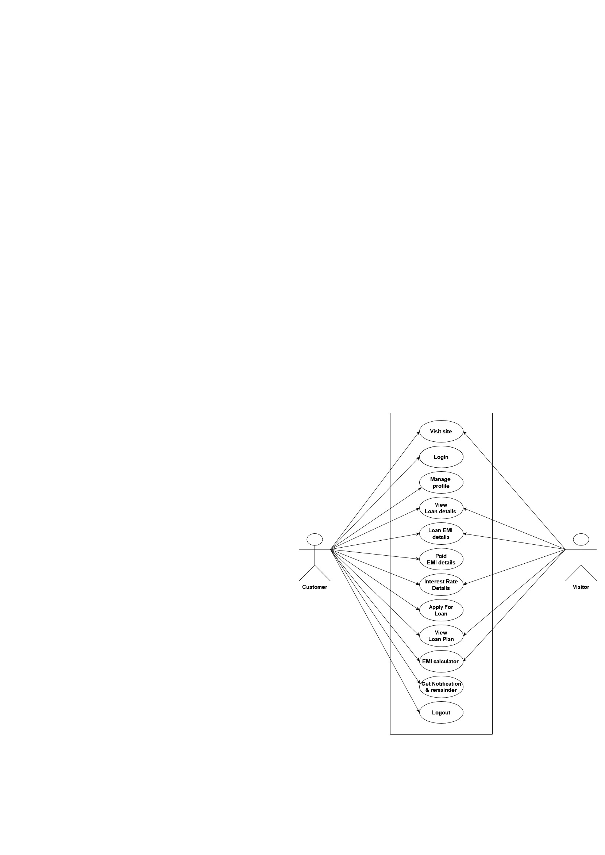

**Figure 3.1: use case diagram customer & visitor side in loan management system**

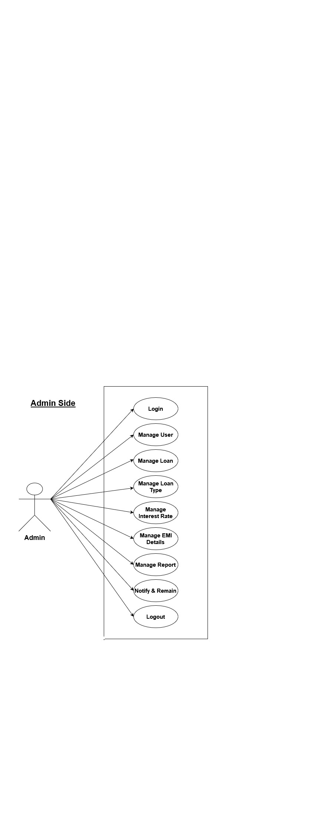

**Figure 3.2: use case diagram Admin side in loan management system**

# ****4. system analysis & design – data-based****

**4.1 DATA MODELING**

**4.1.1 Data Dictionary:**

A Data Dictionary is a collection of names, definitions, and attributes about data

elements that are being used or captured in a database, information system, or part of a research project. It describes the meanings and purposes of data elements within the context of a project, and provides guidance on interpretation, accepted meanings and representation. A Data Dictionary also provides metadata about data elements. The metadata included in a Data Dictionary can assist in defining the scope and characteristics of data elements, as well the rules for their usage and application.

[4.1.1 User_list Table]

|  |  |  |  |
| --- | --- | --- | --- |
| **Name** | **Type** | **Constraints** | **Extra** |
| u_id | Int (30) | PRIMARY | Auto_Increment |
| User_name | Varchar(50) | Not Null | - |
| User_email | Varchar(250) | Not Null | - |
| User_mobile | Varchar(50) | Not Null | - |
| User_pass | Varchar(255) | Not Null | - |
| timestamp | Datetime | Not Null | - |
| User_img | Varcher(1024) | Null | - |
| User_gender | Varchar(20) | Not Null | - |

|  |  |  |  |
| --- | --- | --- | --- |
| **Name** | **Type** | **Constraints** | **Extra** |
| Id | Int(30) | PRIMARY | Auto_Increment |
| Loan_ID | Varchar(50) | Not Null | - |
| U_Name | Varchar(50) | Not Null | - |
| Email | Varchar(50) | Not Null | - |
| Phone | Varchar(15) | Not Null | - |
| Loan_type | Varchar(50) | Not Null | - |
| Loan_amount | Varchar(100) | Not Null | - |
| Loan_term | Int(20) | Not Null | - |
| Interest_Rate | Int(50) | Not Null | - |
| Total_payable_Amount | Varchar(50) | Not Null | - |
| Reason | Varchar(2048) | Not Null | - |
| Status | Varchar(50) | Not Null | - |
| timestamp | datetime | Not Null | - |

[4.1.2 Loan_application Table]

|  |  |  |  |
| --- | --- | --- | --- |
| **Name** | **Type** | **Constraints** | **Extra** |
| Id | Int(30) | PRIMARY | Auto_Increment |
| Name | Varchar(255) | Not Null | - |
| Email | Varchar(50) | Not Null | - |
| Identity | Varchar(1024) | Not Null | - |
| Residence | Varchar(1024) | Not Null | - |
| SalarySlips | Varchar(1024) | Not Null | - |
| Passbook | Varchar(1024) | Not Null | - |
| KYCDocument | Varchar(1024) | Not Null | - |
| timestamp | datetime | Not Null | - |

[4.1.3 Document Table]

|  |  |  |  |
| --- | --- | --- | --- |
| **Name** | **Type** | **Constraints** | **Extra** |
| Id | Int(30) | PRIMARY | Auto_Increment |
| Loan_type | Varchar(255) | Not Null | - |
| Description | text | Not Null | - |
| timestamp | datetime | Not Null | - |

[4.1.4 Loan_type Table]

|  |  |  |  |
| --- | --- | --- | --- |
| **Name** | **Type** | **Constraints** | **Extra** |
| Id | Int(10) | PRIMARY | Auto_Increment |
| Reference_No | Varchar(50) | Not Null | - |
| Loan_ID | Varchar(50) | Not Null | - |
| Name | Varchar(50) | Not Null | - |
| Email | Varchar(50) | Not Null | - |
| Mobile | Varchar(50) | Not Null | - |
| Address | Varchar(100) | Not Null | - |
| Paid_amount | Varchar(50) | Not Null | - |
| City | Varchar(50) | Not Null | - |
| Pay_img | Varchar(1024) | Not Null | - |
| timestamp | datetime | Not Null | - |

[4.1.5 Payments Table]

|  |  |  |  |
| --- | --- | --- | --- |
| **Name** | **Type** | **Constraints** | **Extra** |
| Id | Int(30) | PRIMARY | Auto_Increment |
| months | Int(20) | Not Null | - |
| Interest_percentage | float | Not Null | - |
| Penalty_rate | float | Not Null | - |
| timestamp | datetime | Not Null  [4.1.6 loan_plan Table] | - |

**4.1.2 Entity-Relationship Diagram**

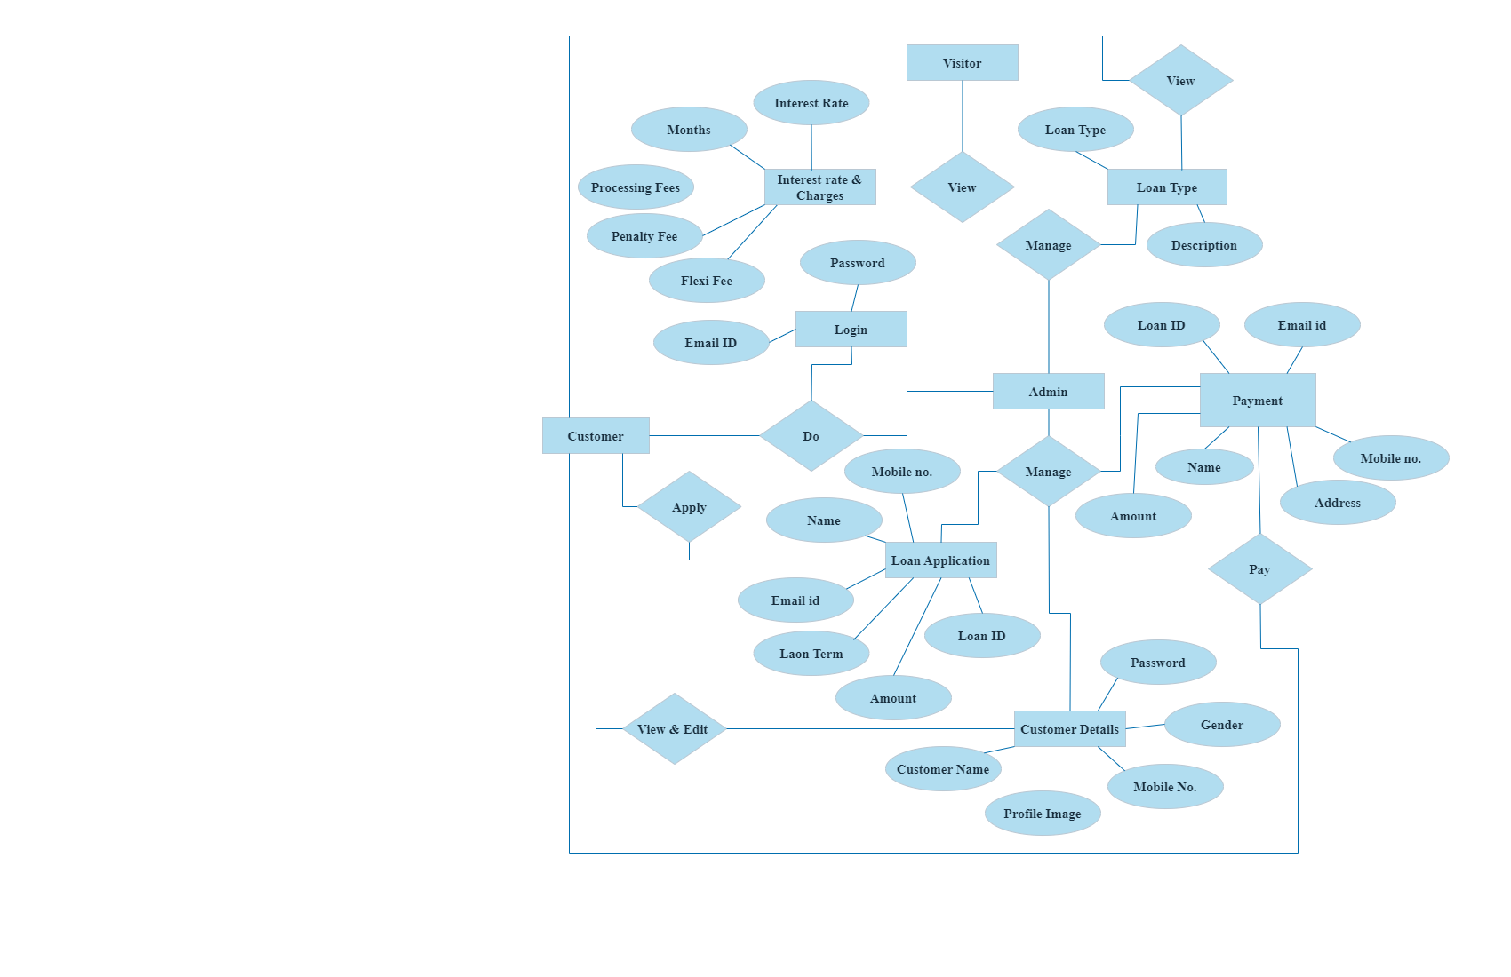

**Figure 4.1: ER Diagram in loan management system**

**4.2 Behavioral Modeling**

**4.2.1 Data Flow Diagram**

**4.2.1.1 Context Level DFD**

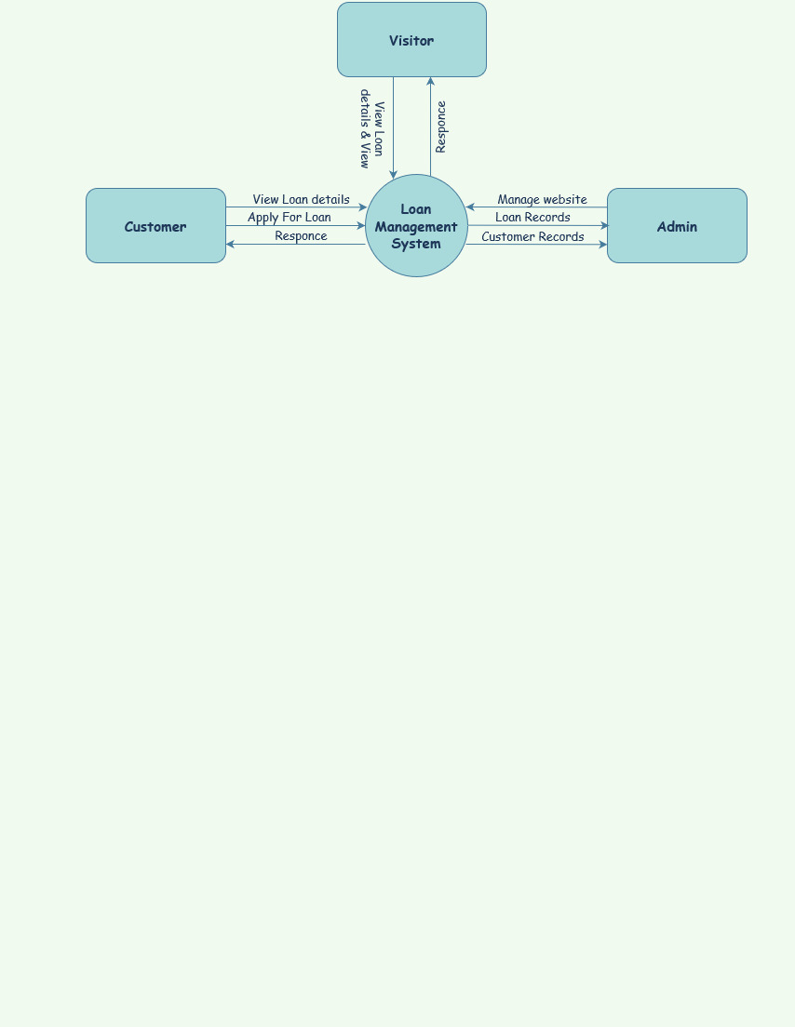

**Figure 4.2: Context Level (DFD Level 0) Diagram**

**4.2.1.2 DFD Level 1:**

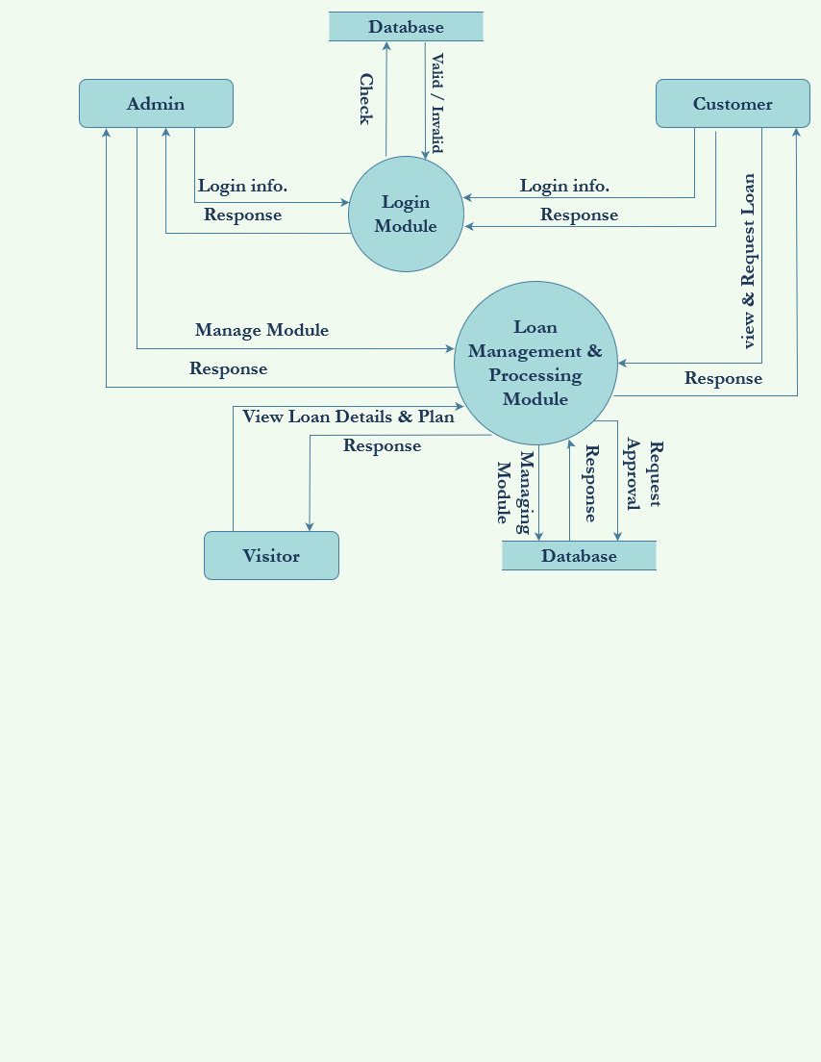

**Figure 4.3: DFD Level 1**

**4.2.1.3 DFD Level 2:**

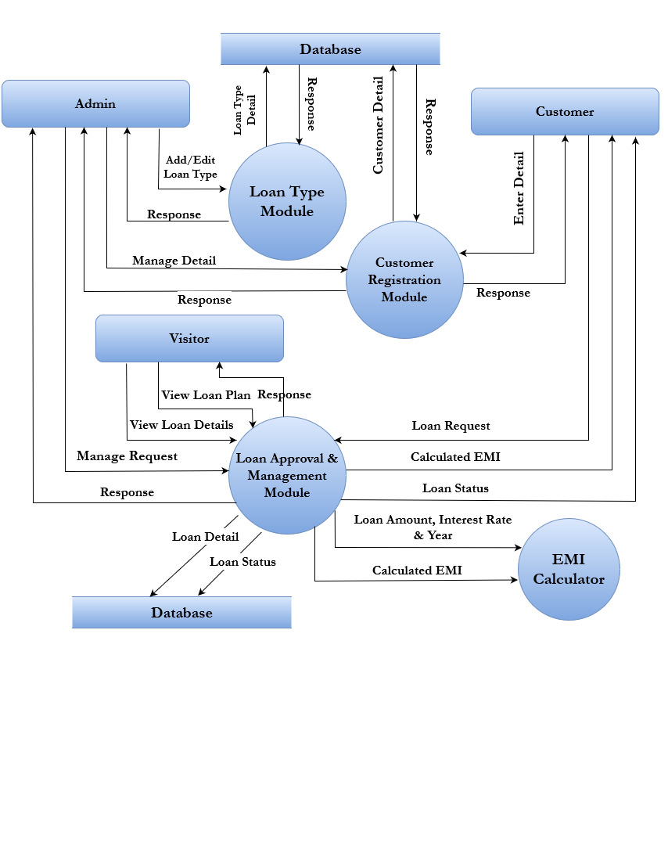

**Figure 4.4: DFD Level 2**

# ****5. system Design – uml****

**5.1 Sequence Diagram:**

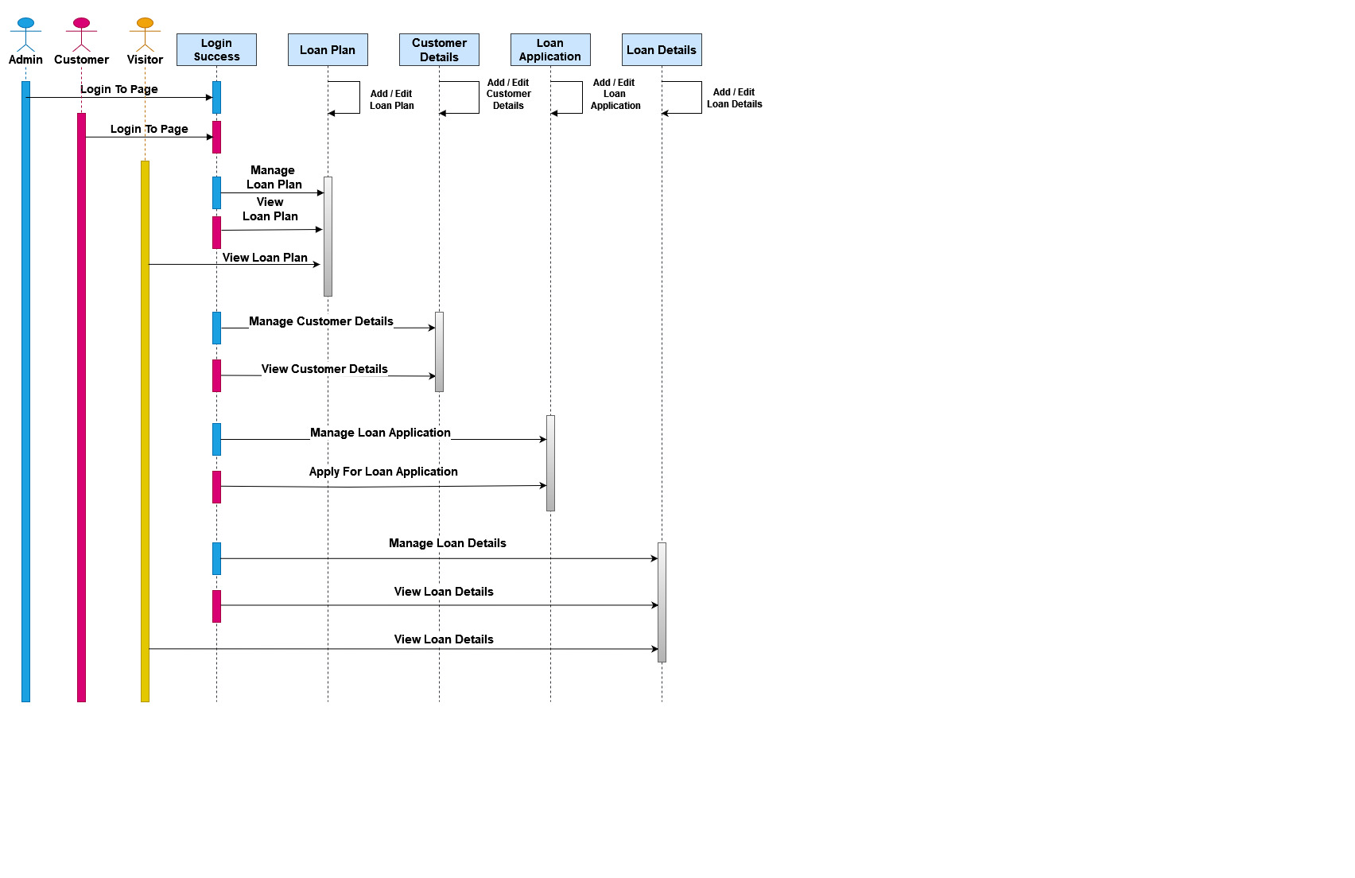

[Figure 5.1 Sequence Diagram]

**5.2 Activity Diagram:**

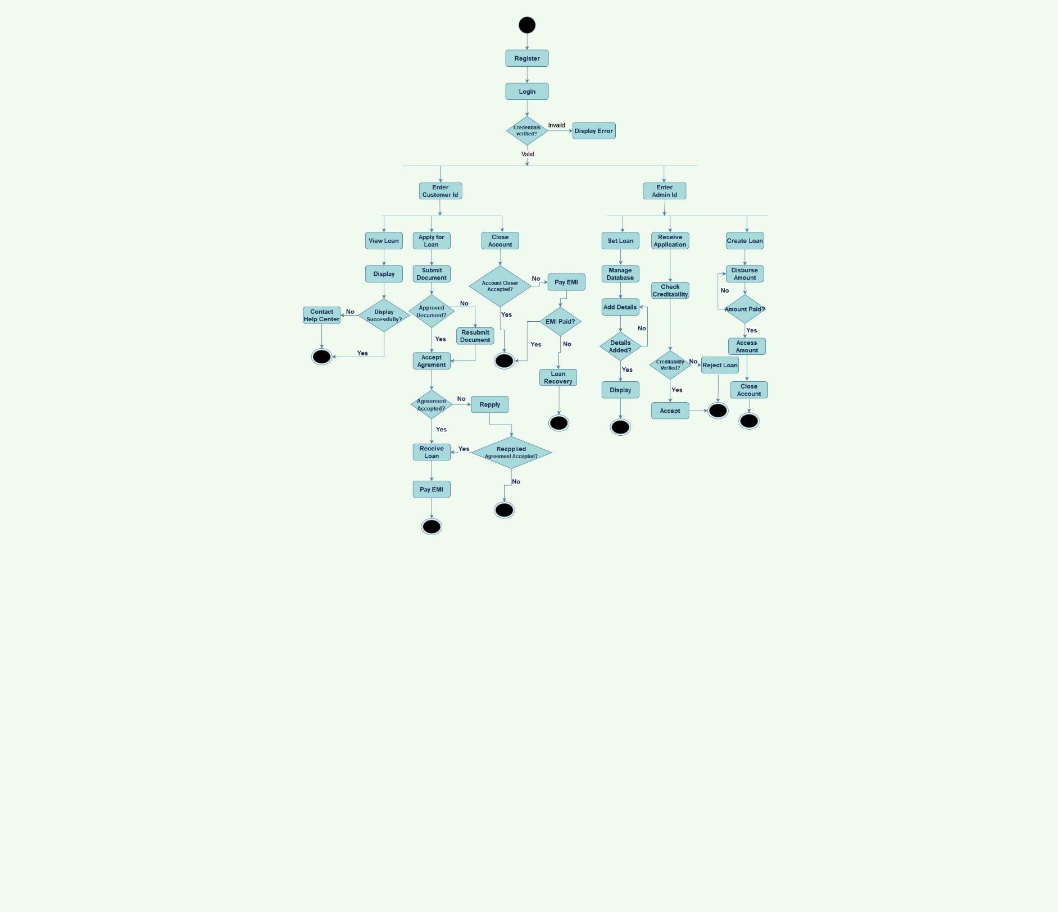

[5.2 Activity Diagram]

# ****6. system interface design****

**6.1 Input-Output Form Design**

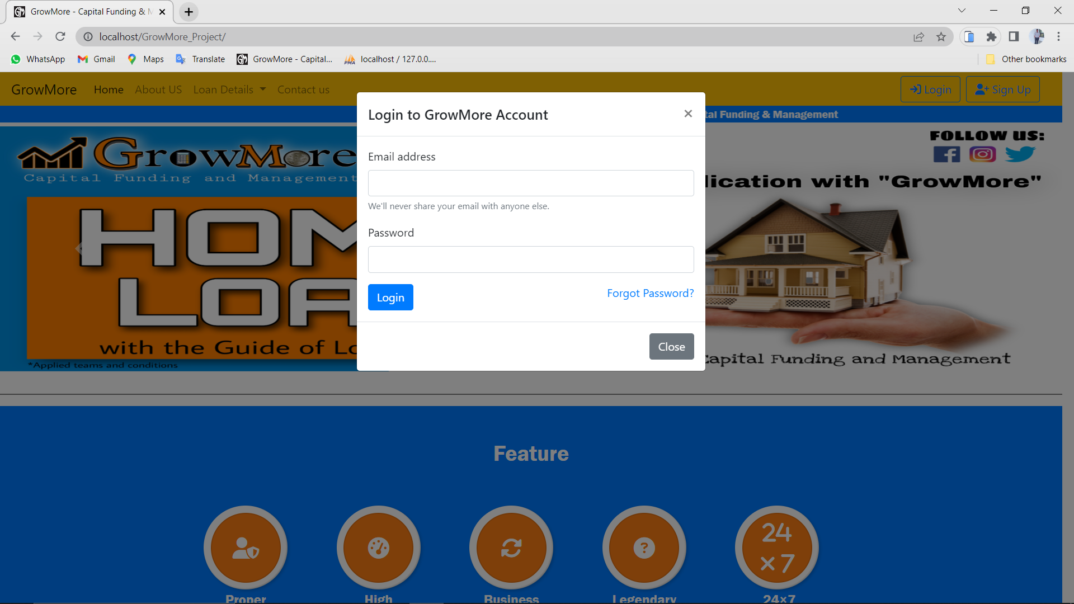

Figure 6.1: Login Form

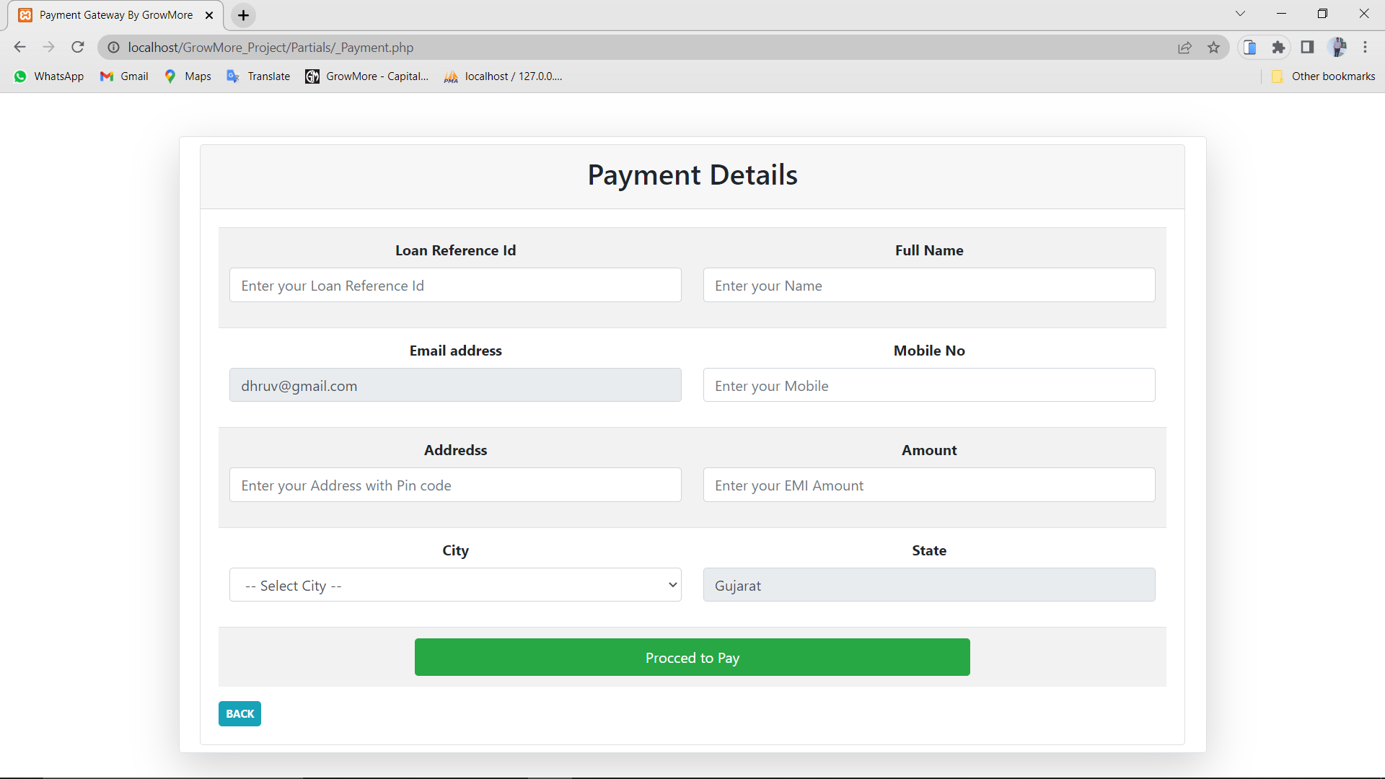

Figure 6.2: Payment Form

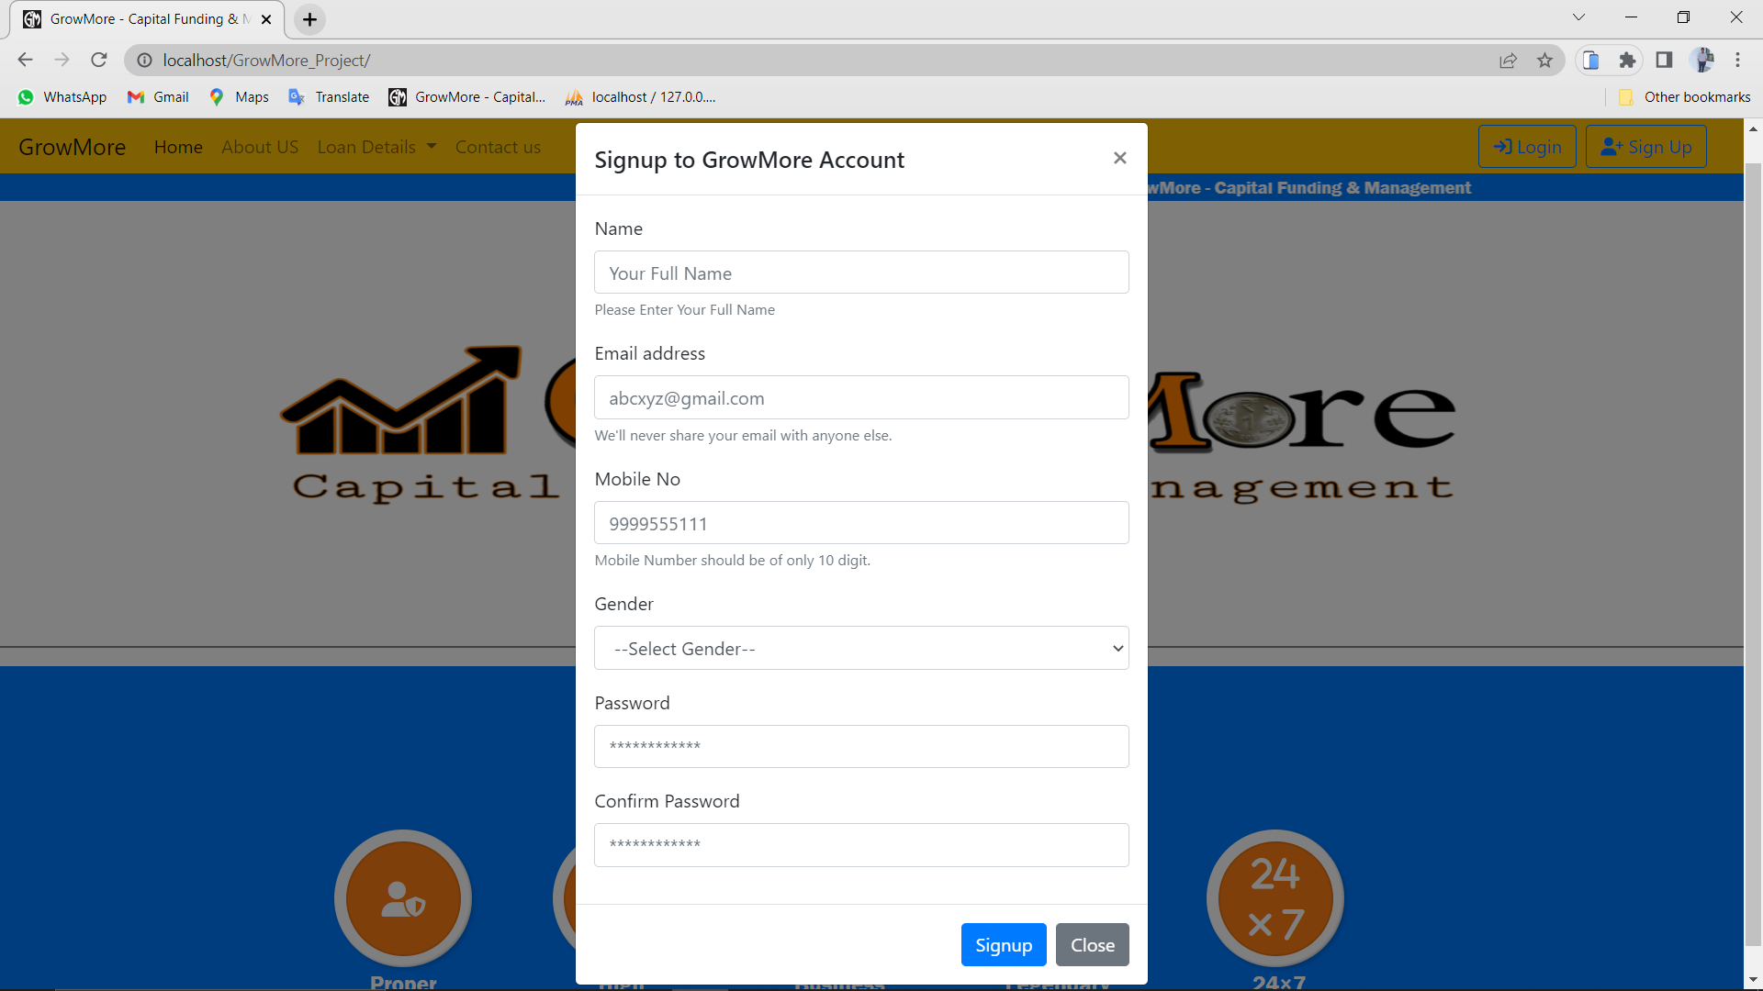

Figure 6.3: Registration Form

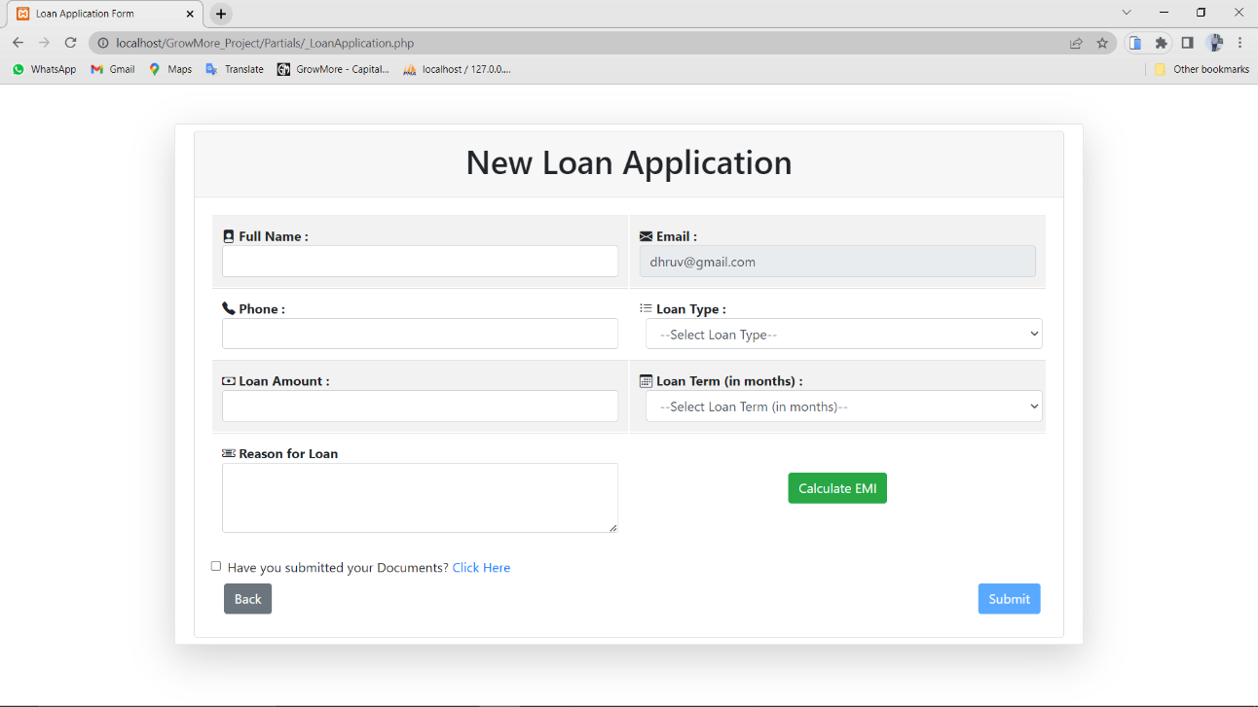

Figure 6.4: Loan Application Form

**6.2 Graphical User Interface Design**

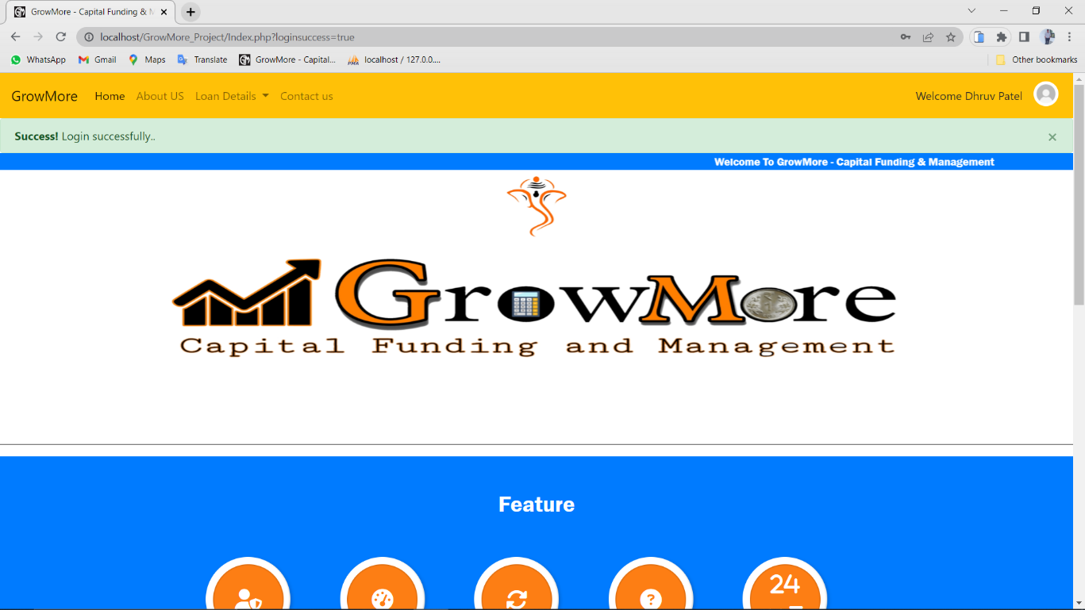

Figure 6.5: Home Page Customer side

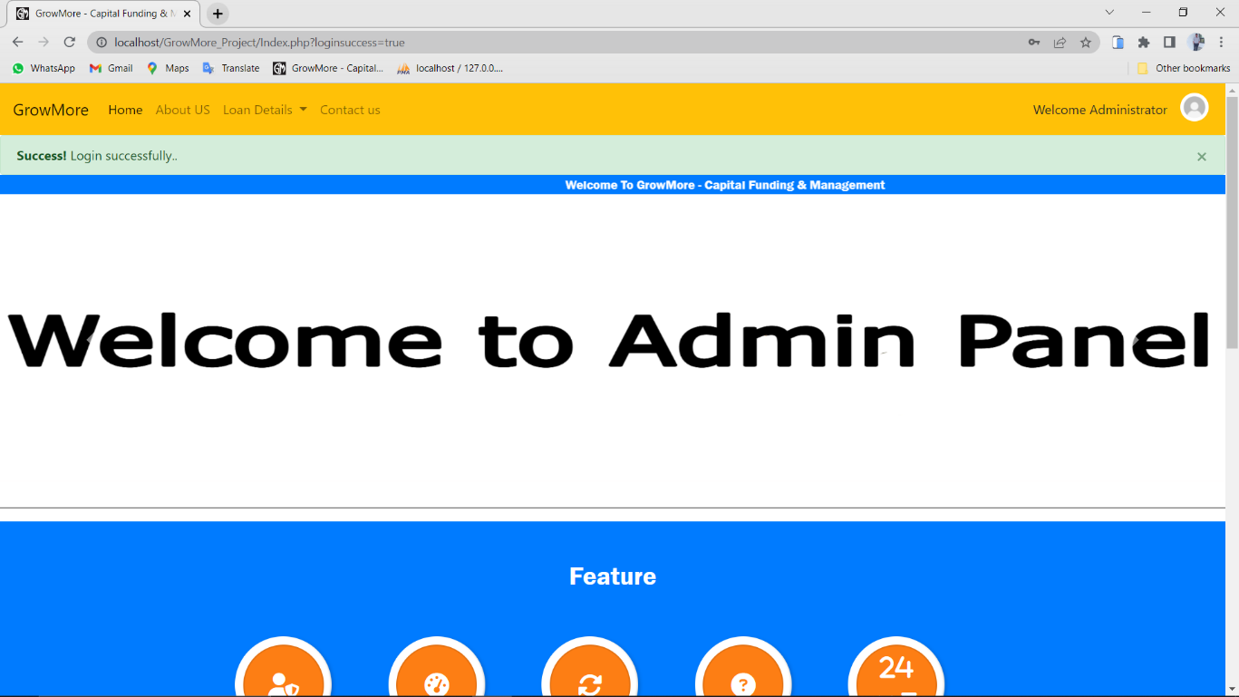

Figure 6.6: Home Page Admin side

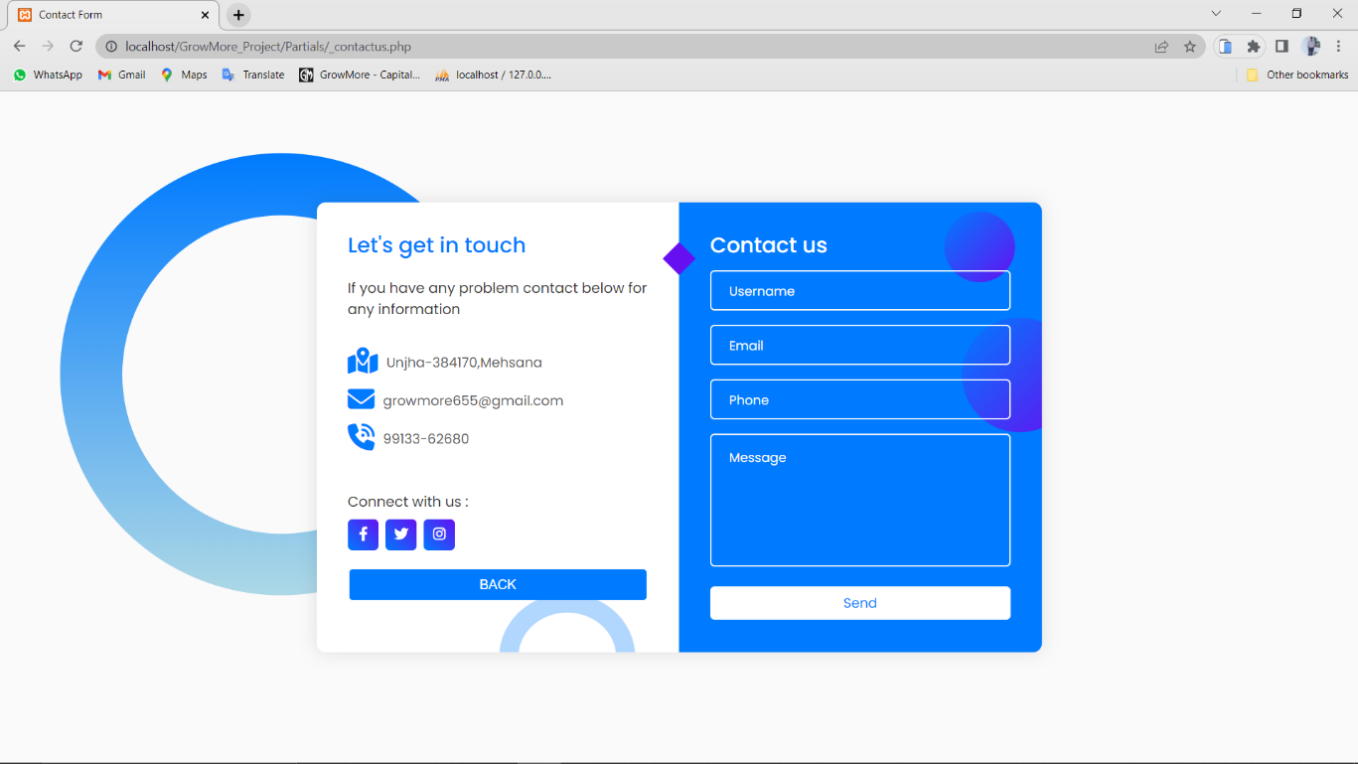

Figure 6.7: Contact US Page

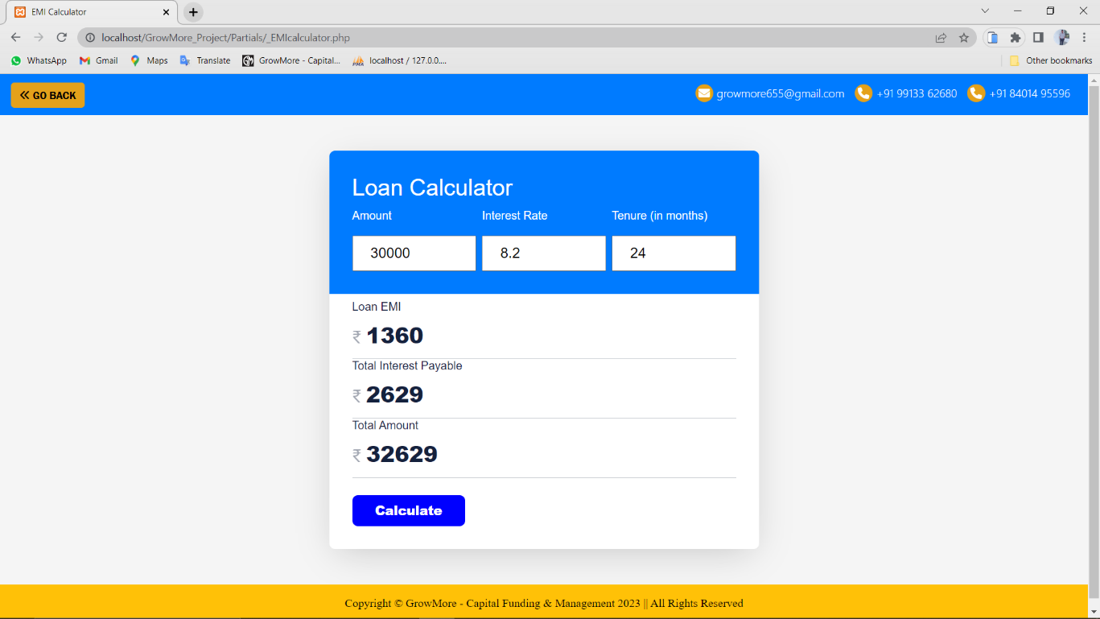

Figure 6.8: EMI Calculator Page

# ****7. Coding module****

**7.1 LOGIN MODULE:**

**Index.php**

<!doctype html>

<html lang="en">

<head>

<link rel="stylesheet" href="./assets/css/MainStyle.css" type="text/css" />

<!-- Icon script-->

<script src="https://kit.fontawesome.com/a7a17df157.js" crossorigin="anonymous"></script>

<!-- Required meta tags -->

<meta charset="utf-8">

<meta http-equiv="X-UA-Compatible" content="IE=edge">

<meta name="viewport" content="width=device-width, initial-scale=1.0">

<!-- Bootstrap CSS -->

<link rel="stylesheet" href="https://cdn.jsdelivr.net/npm/bootstrap@4.5.3/dist/css/bootstrap.min.css"

integrity="sha384-TX8t27EcRE3e/ihU7zmQxVncDAy5uIKz4rEkgIXeMed4M0jlfIDPvg6uqKI2xXr2" crossorigin="anonymous">

<!-- icon and title in title bar-->

<title>GrowMore - Capital Funding & Management</title>

<link rel="icon" type="image" href="assets\images\GM Logo1.jpg" />

<style>

@media screen and (max-width: 900px){

.icon{

flex-direction: column;

}

.icon ul{

flex-direction: column;

}

.icon ul li a{

flex-direction: column;

}

.man-image img{

width: 300px;

}

}

@media screen and (max-width: 1024px){

.man-image img{

width: 300px;

}

}

</style>

</head>

<body>

<?php include 'Partials/_dbconnect.php'; ?>

<?php include 'Partials/_header.php'; ?>

<!--scroll up code Start here -->

<div id="progress">

<span id="progress-value">&#x1F815;</span>

</div>

<!--scroll up code end here -->

<marquee direction="left" class="bg-primary pt-0"

style="font-family:'Franklin Gothic Medium', Poppins,'Arial Narrow', Arial, sans-serif; color:white"

scrollamount="5" behavior="alternate" scrolldelay="100">Welcome To GrowMore - Capital Funding & Management

</marquee>

<!--side area Start here -->

<?php

if (isset($_SESSION['loggedin']) && $_SESSION['loggedin'] == true) {

$user_email = $_SESSION['useremail'];

$sql = "SELECT * FROM `user_list` WHERE user_email = '$user_email'";

$query = mysqli_query($conn, $sql);

$result = mysqli_fetch_assoc($query);

if($result['user_name'] == "Administrator"){

echo ' <div class="side pb-3">

<div id="carouselExampleIndicators" class="carousel slide" data-ride="carousel">

<ol class="carousel-indicators">

<li data-target="#carouselExampleIndicators" data-slide-to="0" class="active"></li>

<li data-target="#carouselExampleIndicators" data-slide-to="1"></li>

<li data-target="#carouselExampleIndicators" data-slide-to="2"></li>

</ol>

<div class="carousel-inner">

<div class="carousel-item active">

<img src="assets\images/adminpanel.jpg" style="width:2400px; height:350px;"

class="d-block w-100" alt="...">

</div>

<div class="carousel-item ">

<img src="assets\images/GrowMore.jpg" style="width:1500px; height:350px;" class="d-block w-100"

alt="...">

</div>

<div class="carousel-item">

<img src="assets\images/Vehicle_loan GrowMore.jpg" style="width:2400px; height:350px;"

class="d-block w-100" alt="...">

</div>

</div>

<a class="carousel-control-prev" href="#carouselExampleIndicators" role="button" data-slide="prev">

<span class="carousel-control-prev-icon" aria-hidden="true"></span>

<span class="sr-only">Previous</span>

</a>

<a class="carousel-control-next" href="#carouselExampleIndicators" role="button" data-slide="next">

<span class="carousel-control-next-icon" aria-hidden="true"></span>

<span class="sr-only">Next</span>

</a>

</div>

</div>';

}

else{

echo '<div class="side pb-3">

<div id="carouselExampleIndicators" class="carousel slide" data-ride="carousel">

<ol class="carousel-indicators">

<li data-target="#carouselExampleIndicators" data-slide-to="0" class="active"></li>

<li data-target="#carouselExampleIndicators" data-slide-to="1"></li>

<li data-target="#carouselExampleIndicators" data-slide-to="2"></li>

</ol>

<div class="carousel-inner">

<div class="carousel-item active">

<img src="assets\images/GrowMore.jpg" style="width:1500px; height:350px;" class="d-block w-100"

alt="...">

</div>

<div class="carousel-item">

<img src="assets\images/Home_Loan GrowMore.jpg" style="width:2400px; height:350px;"

class="d-block w-100" alt="...">

</div>

<div class="carousel-item">

<img src="assets\images/Vehicle_loan GrowMore.jpg" style="width:2400px; height:350px;"

class="d-block w-100" alt="...">

</div>

</div>

<a class="carousel-control-prev" href="#carouselExampleIndicators" role="button" data-slide="prev">

<span class="carousel-control-prev-icon" aria-hidden="true"></span>

<span class="sr-only">Previous</span>

</a>

<a class="carousel-control-next" href="#carouselExampleIndicators" role="button" data-slide="next">

<span class="carousel-control-next-icon" aria-hidden="true"></span>

<span class="sr-only">Next</span>

</a>

</div>

</div>';

}

}

else{

echo'

<div class="side pb-3">

<div id="carouselExampleIndicators" class="carousel slide" data-ride="carousel">

<ol class="carousel-indicators">

<li data-target="#carouselExampleIndicators" data-slide-to="0" class="active"></li>

<li data-target="#carouselExampleIndicators" data-slide-to="1"></li>

<li data-target="#carouselExampleIndicators" data-slide-to="2"></li>

</ol>

<div class="carousel-inner">

<div class="carousel-item active">

<img src="assets\images/GrowMore.jpg" style="width:1500px; height:350px;" class="d-block w-100"

alt="...">

</div>

<div class="carousel-item">

<img src="assets\images/Home_Loan GrowMore.jpg" style="width:2400px; height:350px;"

class="d-block w-100" alt="...">

</div>

<div class="carousel-item">

<img src="assets\images/Vehicle_loan GrowMore.jpg" style="width:2400px; height:350px;"

class="d-block w-100" alt="...">

</div>

</div>

<a class="carousel-control-prev" href="#carouselExampleIndicators" role="button" data-slide="prev">

<span class="carousel-control-prev-icon" aria-hidden="true"></span>

<span class="sr-only">Previous</span>

</a>

<a class="carousel-control-next" href="#carouselExampleIndicators" role="button" data-slide="next">

<span class="carousel-control-next-icon" aria-hidden="true"></span>

<span class="sr-only">Next</span>

</a>

</div>

</div>

';

}

?>

<!--side area end here -->

<hr style="width:100%; height:2px; border-width:0; color:gray; background-color:gray">

<!--feature area start here -->

<div class="features bg-primary py-5">

<h2 class="text-center "

style="font-family:'Franklin Gothic Medium', Poppins,'Arial Narrow', Arial, sans-serif; color:white;">

Feature

</h2>

<div class="icon text-center pt-5">

<ul> <li>

<a href="#"><span><i class="fa-solid fa-user-shield"></i></span></a>

<div class="tooltrip text-center">Proper <br> Security</div>

</li><li>

<a href="#"><span><i class="fa-solid fa-gauge-high"></i></span></a>

<div class="tooltrip text-center">High<br>Performance </div>

</li><li>

<a href="#"><span><i class="fa-solid fa-rotate"></i></span></a>

<div class="tooltrip text-center">Business <Br> Sustainability </div></li><li>

<a href="#"><span><i class="fa-solid fa-circle-question"></i></span></a>

<div class="tooltrip text-center">Legendary <br> Support </div>

</li><li>

<a href="#"><span><i class="fa-solid fa-2"></i><i class="fa-solid fa-4"></i><br><I class="fa-solid fa-xmark"></i>&nbsp;<i class="fa-solid fa-7"></i></span></a>

<div class="tooltrip text-center">24×7 <br> service available</div>

</li></ul>

</div></div>

<!--feature area end here -->

<hr style="width:100%; height:3px; border-width:0; color:gray; background-color:gray">

<!--why choose us area start here -->

<div class="section whychoose-area pt-5 bg-primary text-light">

<div class="container">

<div class="row">

<div class="col-sm-12 text-center">

<div class="section-title">

<h2 class="text-warning"

style="font-family:'Franklin Gothic Medium', Poppins,'Arial Narrow', Arial, sans-serif;">Why

Choose <span style="color:black;">Us</span></h2>

<p class="text-light">Easy | Fast | Quick</p>

</div></div></div>

<div class="row row-normalize mt-3">

<div class="col-md-6 col-sm-12">

<div class="man-image mt-2 pt-2">

<img src="assets/images/woman.png" alt="">

</div></div>

<div class="col-md-6 col-sm-12">

<div class="whychoose-list mt-5 pt-5">

<ul class="navbar-nav mr-auto">

<li class="nav-item active">

<div class="media">

<div class="icon1" style="color:black;">

<i class="fa-solid fa-certificate pt-2"></i></div>

<div class="media-body ml-3">

<h4 style="font-family:'Franklin Gothic Medium', Poppins,'Arial Narrow', Arial, sans-serif; color:black;"

class="media-heading">Good Performance</h4>

<p style="font-family:'Montserrat', sans-serif">Becuase we have good performance

and wonderful customer support.Our Employees taking Care of you things</p>

</div></div>

</li><li>

<div class="media">

<div class="icon1" style="color:black;">

<i class="fa-solid fa-chart-line pt-2"></i></div>

<div class="media-body ml-3">

<h4 style="font-family:'Franklin Gothic Medium', Poppins,'Arial Narrow', Arial, sans-serif;color:black;"

class="media-heading">Easy Documentation</h4>

<p style="font-family:'Montserrat', sans-serif">We gives you easy process for

request a loan and higher support</p>

</div></div>

</li> <li>

<div class="media">

<div class="icon1" style="color:black;">

<i class="fa-regular fa-circle-question pt-2"></i>

</div>

<div class="media-body ml-3">

<h4 style="font-family:'Franklin Gothic Medium', Poppins,'Arial Narrow', Arial, sans-serif; color:black;"

class="media-heading">Creative Technology Support</h4>

<p style="font-family:'Montserrat', sans-serif">Technical Support from us.Users

can easily request for loans online and verify their documents on our site

</p>

</div></div>

</li></ul>

</div></div>

</div></div></div>

<!--why choose us area end here -->

<?php include 'Partials/_footer.php'; ?>

<!-- Optional JavaScript; choose one of the two! -->

<!-- Option 1: jQuery and Bootstrap Bundle (includes Popper) -->

<script src="https://code.jquery.com/jquery-3.5.1.slim.min.js"

integrity="sha384-DfXdz2htPH0lsSSs5nCTpuj/zy4C+OGpamoFVy38MVBnE+IbbVYUew+OrCXaRkfj" crossorigin="anonymous">

</script>

<script src="https://cdn.jsdelivr.net/npm/bootstrap@4.5.3/dist/js/bootstrap.bundle.min.js"

integrity="sha384-ho+j7jyWK8fNQe+A12Hb8AhRq26LrZ/JpcUGGOn+Y7RsweNrtN/tE3MoK7ZeZDyx" crossorigin="anonymous">

</script>

<script src="assets/JS/script.js"></script>

</body>

</html>

**_loginmodal.php**

<div class="modal fade" id="loginModal" tabindex="-1" role="dialog" aria-labelledby="loginModalLabel"

aria-hidden="true">

<div class="modal-dialog">

<div class="modal-content">

<div class="modal-header">

<h5 class="modal-title" id="loginModalLabel">Login to GrowMore Account</h5>

<button type="button" class="close" data-dismiss="modal" aria-label="Close">

<span aria-hidden="true">&times;</span>

</button></div>

<form action="/GrowMore_Project/Partials/_handleLogin.php" method="post">

<div class="modal-body">

<div class="form-group">

<label for="loginEmail">Email address</label>

<input type="email" class="form-control" id="loginEmail" name="loginEmail"

aria-describedby="emailHelp">

<small id="emailHelp" class="form-text text-muted">We'll never share your email with anyone

else.</small>

</div>

<div class="form-group">

<label for="loginPass">Password</label>

<input type="password" class="form-control" id="loginPass" name="loginPass"></div>

<a href="Partials/_PassRest.php" class="float-right">Forgot Password?</a>

<button type="submit" class="btn btn-primary ">Login</button>

</div>

<div class="modal-footer">

<button type="button" class="btn btn-secondary" data-dismiss="modal">Close</button>

</div></form></div></div></div>

**_handlelogin.php**

<?php

$showError = "false";

if($_SERVER["REQUEST_METHOD"] == "POST"){

include '_dbconnect.php';

$email = $_POST['loginEmail'];

$pass = $_POST['loginPass'];

$sql = "SELECT * FROM `user_list` WHERE `user_email`='$email'";

$result= mysqli_query($conn, $sql);

$numRows = mysqli_num_rows($result);

if($numRows==1) {

$row = mysqli_fetch_assoc($result);

if(password_verify($pass, $row['user_pass'])) {

session_start();

$_SESSION['loggedin'] = true;

$_SESSION['useremail'] = $email;

header("Location:\GrowMore_Project\Index.php?loginsuccess=true");

exit();

}

else{

$showError = "Password do not match";

session_start();

$_SESSION['status'] = "Password do not match";

header("Location:\GrowMore_Project\Index.php?loginsuccess=false&error=$showError");

}

}

else{

$showError = "User Not Found";

session_start();

$_SESSION['status'] = "User Not Found";

header("Location:\GrowMore_Project\Index.php?loginsuccess=false&error=$showError");

}

}

**7.2 LOAN APPLICATION MODULE:**

**_loanapplication.php**

<?php

error_reporting(0);

include '_dbconnect.php';

$sql1 = "SELECT * FROM `loan_plan`";

$query1 = mysqli_query($conn, $sql1);

$result1 = mysqli_num_rows($query1);

$sql = "SELECT * FROM `loan_types`";

$query = mysqli_query($conn, $sql);

$result = mysqli_num_rows($query);

session_start();

if (isset($_SESSION['loggedin']) && $_SESSION['loggedin'] == true) {

$user_email = $_SESSION['useremail'];

$ql = "SELECT * FROM `user_list` WHERE user_email = '$user_email'";

$que = mysqli_query($conn, $ql);

$res = mysqli_fetch_assoc($que);

$id = $res['u_id'];

$u_email = $res['user_email'];

?>

<!DOCTYPE html>

<html><head>

<!-- Required meta tags -->

<meta charset="utf-8">

<meta name="viewport" content="width=device-width, initial-scale=1, shrink-to-fit=no">

<!-- Bootstrap CSS -->

<link rel="stylesheet" href="https://cdn.jsdelivr.net/npm/bootstrap@4.5.3/dist/css/bootstrap.min.css" integrity="sha384-TX8t27EcRE3e/ihU7zmQxVncDAy5uIKz4rEkgIXeMed4M0jlfIDPvg6uqKI2xXr2" crossorigin="anonymous">

<title>Loan Application Form</title>

<link rel="stylesheet" type="text/css" href="../assets/css/bootstrap-icons.css">

<link rel="stylesheet" href="https://cdn.jsdelivr.net/npm/bootstrap-icons@1.10.5/font/bootstrap-icons.css">

<style>

th {

width: 500px;

}

.popup {

width: 400px;

background-color: #fff;

border-radius: 6px;

position: absolute;

top: 50%;

left: 50%;

transform: translate(-50%, -50%) scale(1);

text-align: center;

padding: 0 30px 30px;

color: #333;

visibility: visible;

transition: transform 0.4s,top 0.4s;

}

.close-popup{

visibility:hidden ;

top: 0%;

transform: translate(-50%, -50%) scale(0.1);

}

.popup img{

width: 100px;

margin-top: -50px;

border-radius: 60%;

box-shadow: 0 2px 5px rgba(0, 0, 0, 0.2);

}

.popup h2{

font-size: 38px;

margin: 10px 0 10px;

font-weight: 500;

}

.popup button{

width: 100%;

margin-top: 10px;

padding: 10px 0;

border: 0;

font-size: 18px;

outline: none;

border-radius: 4px;

cursor: pointer;

box-shadow: 0 5px 5px rgba(0, 0, 0, 0.2);

}

</style></head>

<body>

<!------------------------------------------------ Main Body Start here ------------------------------------------------->

<div class="container">

<div class="row border rounded mx-auto mt-5 p-2 shadow-lg">

<div class="col-md-12">

<div class="card">

<?php

if (isset($_SESSION['status']) && $_SESSION['status'] != '') { ?>

<div class="alert alert-warning alert-dismissible fade show" role="alert">

<strong>Hey!</strong> <?php echo $_SESSION['status']; ?>

<button type="button" class="close" data-dismiss="alert" aria-label="Close">

<span aria-hidden="true">&times;</span>

</button>

</div>

<?php

unset($_SESSION['status']);

}

?>

<div class="card-header text-center">

<h1>New Loan Application</h1>

</div>

<div class="card-body">

<form action="" method="post" onsubmit="return validation()" name="myfrm">

<table class="table table-striped text-left" style=" border-collapse:separate;">

<tr>

<th><i class="bi bi-file-person-fill"></i> Full Name :<br>

<input class="form-control" type="text" id="Name" name="Name"value="<?php if(isset($_POST['Name'])) echo $_POST['Name']; ?>" required>

</th>

<th><i class="bi bi-envelope-fill"></i> Email :<br>

<input class="form-control" type="text" id="Email" name="Email" value="<?php echo $u_email ?>" readonly>

</th></tr>

<tr>

<th><i class="bi bi-telephone-fill"></i> Phone :<br>

<input class="form-control" type="text" id="Phone" name="Phone" value="<?php if(isset($_POST['Phone'])) echo $_POST['Phone']; ?>" required>

</th>

<th><i class="bi bi-list-ul"></i> Loan Type :<br>

<select class="form-control ml-2" aria-label="Default select example" name="Type" id="Type" required>

<option value="">--Select Loan Type--</option>

<?php

for ($i = 1; $i <= $result; $i++) {

$row1 = mysqli_fetch_array($query);

?>

<option value="<?php echo $row1['loan_type'] ?>" <?php echo(isset($_POST['Type']) && $_POST['Type'] == $row1['loan_type']) ? 'selected' : ''; ?> > <?php echo $row1['loan_type'] ?></option>

<?php } ?>

</select>

</th>

</tr>

<tr>

<th><i class="bi bi-cash"></i> Loan Amount :<br>

<input class="form-control" type="number" id="Amount" name="Amount" value="<?php if(isset($_POST['Amount'])) echo $_POST['Amount']; ?>" required>

</th>

<th><i class="bi bi-calendar3"></i> Loan Term (in months) :<br>

<select class="form-control ml-2" aria-label="Default select example" name="Term" id="Term" required>

<option value="">--Select Loan Term (in months)--</option>

<?php

for ($i = 1; $i <= $result1; $i++) {

$row = mysqli_fetch_array($query1);

?>

<option value="<?php echo $row['months'] ?>" <?php echo(isset($_POST['Term']) && $_POST['Term'] == $row['months']) ? 'selected' : ''; ?> ><?php echo $row['months'] ?> Months</option>

<?php } ?></select></th></tr>

<tr>

<th><i class="bi bi-ticket-detailed"></i> Reason for Loan<br>

<textarea class="form-control" id="Reason" name="Reason" rows="3" required><?php echo isset($_POST['Reason']) ? htmlspecialchars($_POST['Reason']) : '' ?></textarea>

</th>

<th style="text-align: center;" class="align-middle">

<button type="submit" class="btn btn-success" name="EMI" id="EMI">Calculate EMI</button>

</th>

</tr>

<?php if (isset($_POST['EMI'])) {

/* $name = $_POST['Name'];

$email = $_POST['Email'];

$phone = $_POST['Phone'];

$type = $_POST['Type'];

$reason = $_POST['Reason']; */

$amount = $_POST['Amount'];

$term = $_POST['Term'];

$sql2 = "SELECT * FROM `loan_plan` WHERE months = '$term'";

$query2 = mysqli_query($conn, $sql2);

$result2 = mysqli_fetch_assoc($query2);

$rate = $result2['interest_percentage'];

$penalty = $result2['penalty_rate'];

$interestrate = ($rate / 100) / 12;

if (empty($amount) || empty($term)) {

echo '<div class="alert alert-warning alert-dismissible fade show" role="alert">

<strong>Hey!</strong>Loan Amount or Loan Term Field is Empty...

<button type="button" class="close" data-dismiss="alert" aria-label="Close">

<span aria-hidden="true">&times;</span>

</button>

</div>';

} else {

$EMI = $amount * $interestrate * pow(1 + $interestrate, $term) / (pow(1 + $interestrate, $term) - 1);

$TotalEmi = round($term * $EMI);

$PayableAmount = round($TotalEmi - $amount);

echo '<tr>

<td> Loan EMI :<br><b>' . round($EMI) . '</b></td>

<td> Total Interest Payable :<br><b>' . $PayableAmount . '</b> </td>

</tr><tr>

<td> Total Amount :<br><b>' . $TotalEmi . '</b></td>

<th><h5 class="mb-0"><small>Interest: <b>' . $rate . ' % </b></small></h5>

<h5 class="mb-0"><small>Over dure Penalty: <b>' . $penalty . ' %</b></small></h5></th>

</tr>';

} } ?>

</table>

<div class="form-check">

<input class="form-check-input" type="checkbox" value="" id="check" name="check" onclick="enable()" required>

<label class="form-check-label" for="defaultCheck1">Have you submitted your Documents? <a href="_Documents.php">Click Here</a></label>

</div>

<div class="p-2">

<button type="submit" class="btn btn-primary float-right" name="submit" id="submit" disabled="true">Submit</button>

<a href="_Loans.php"><button type="button" class="btn btn-secondary ml-2">Back</button></a>

</div>

</form>

<?php

if (isset($_POST['submit'])) {

$name = $_POST['Name'];

$email = $_POST['Email'];

$phone = $_POST['Phone'];

$type = $_POST['Type'];

$loan_amount = $_POST['Amount'];

$loan_term = $_POST['Term'];

$reason = $_POST['Reason'];

$code = rand(0, 999999);

$loan_id = "REFID" . $code;

$sql2 = "SELECT * FROM `loan_plan` WHERE months = '$loan_term'";

$query2 = mysqli_query($conn, $sql2);

$result2 = mysqli_fetch_assoc($query2);

$rate = $result2['interest_percentage'];

$penalty = $result2['penalty_rate'];

$interestrate = ($rate / 100) / 12;

$EMI = $loan_amount * $interestrate * pow(1 + $interestrate, $loan_term) / (pow(1 + $interestrate, $loan_term) - 1);

$TotalEmi = round($loan_term * $EMI);

$PayableAmount = round($TotalEmi - $loan_amount);

if(isset($_POST['check'])){

$ql1 = "SELECT * FROM `document` WHERE Email = '$email'";

$que1 = mysqli_query($conn, $ql1);

$numRows = mysqli_num_rows($que1);

if($numRows > 0){

$sql = "INSERT INTO `loan_application` (`Loan_ID`,`U_Name`,`Email`,`Phone`,`Loan_type`,`Loan_amount`,`Loan_term`,`Interest_Rate`,`Total_payable_Amount`,`Reason`,`Status`,`timestamp`) VALUES ('$loan_id','$name','$email','$phone','$type','$loan_amount','$loan_term','$rate','$TotalEmi','$reason','Pending',current_timestamp())";

$query_run = mysqli_query($conn, $sql);

echo '<div class="popup" id="popup">

<img src="..\assets\images\tick1.png" alt="">

<h2>Success!</h2>

<h5> Loan ID : '.$loan_id .'</h5>

<p> Loan Type : '.$type .'<br> Loan Amount : '.$loan_amount .'<br>Loan term : '.$loan_term .'<br> Interest Rate : '.$rate .'<br> Penalty Rate : '.$penalty .'<br>

<b>Total Amount : '.$TotalEmi .'</b><br>Thank you for apply Loan Application.<br>Your Application is approved/rejected within 24 to 72 hours..</p>

<button type="button" class="btn btn-success"onclick="closePopup()"> OK</button>

</div>';

}

else{

echo '<div class="alert alert-warning alert-dismissible fade show" role="alert">

<strong>Hey!</strong> Documents are not submited. Please submit your document first...

<button type="button" class="close" data-dismiss="alert" aria-label="Close">

<span aria-hidden="true">&times;</span></button>

</div>';

} } } ?>

</div </div> </div> </div> </div>

<?php } ?>

<!------------------------------------------------ Main Body End here ------------------------------------------------->

<!-- Optional JavaScript; choose one of the two! -->

<!-- Option 2: jQuery, Popper.js, and Bootstrap JS -->

<script src="https://code.jquery.com/jquery-3.6.4.js" integrity="sha256-a9jBBRygX1Bh5lt8GZjXDzyOB+bWve9EiO7tROUtj/E=" crossorigin="anonymous"></script>

<script src="https://cdn.jsdelivr.net/npm/popper.js@1.16.1/dist/umd/popper.min.js" integrity="sha384-9/reFTGAW83EW2RDu2S0VKaIzap3H66lZH81PoYlFhbGU+6BZp6G7niu735Sk7lN" crossorigin="anonymous"></script>

<script src="https://cdn.jsdelivr.net/npm/bootstrap@4.5.3/dist/js/bootstrap.min.js" integrity="sha384-w1Q4orYjBQndcko6MimVbzY0tgp4pWB4lZ7lr30WKz0vr/aWKhXdBNmNb5D92v7s" crossorigin="anonymous"></script>

<script>

function enable(){

var check = document.getElementById("check");

var btn = document.getElementById("submit");

if(check.checked){

btn.removeAttribute("disabled");

}else{

btn.disabled="true";

}

}

let popup =document.getElementById("popup");

function closePopup(){

popup.classList.add("close-popup");

}

function validation() {

var phone = document.forms['myfrm']['Phone'];

var get_num = String(phone.value).charAt(0);

var first_num = Number(get_num);

if (isNaN(phone.value) || phone.value.length != 10 || first_num < 6) {

alert('Invalid Phone Number');

return false;

}

return true;

}

</script>

</body>

</html>

# ****8.**** Testing

**8.1 SAMPLE TEST CASE:**

**8.1.1 Test-1:**

**Test Case ID :-** test01

**Module Name :-** Login

**Test Title :-** Verify id and Password for login

**Description :-** test the login function

**Pre-Condition :-** Email id and Pssword

|  |  |  |  |  |
| --- | --- | --- | --- | --- |
| **Step No** | **Step Name** | **Test Data** | **Result** | **Status** |
| 1. | Enter Email Id | abc@gmail.com | - |  |
| 2. | Enter Password | abc@123 | - |  |
| 3. | Click on Login | Click on Login | Login Successful | Pass |

**8.1.2 Test-2:**

**Test Case ID :-** test02

**Module Name :-** EMI Calculator

**Test Title :-** View EMI for Loan Amount

**Description :-** Test the EMI Calculator

**Pre-Condition :-** Enter Loan Amount, Tenure, Interest rate

\

|  |  |  |  |  |
| --- | --- | --- | --- | --- |
| **Step No** | **Step Name** | **Test Data** | **Result** | **Status** |
| 1. | Enter Loan Amount | 30000 | - |  |
| 2. | Enter Interest Rate | 8.2 | - |  |
| 3. | Enter Tenure | 24 | - |  |
| 4. | Click on Calculate | Click on Calculate | EMI Calculated Successful | Pass |

**8.1.3 Test-3:**

**Test Case ID :-** test03

**Module Name :-** Loan Application

**Test Title :-** Apply Loan Application

**Description :-** test the Loan Application function

**Pre-Condition :-** Enter Loan Amount ,Type, Term, Name,Reason

|  |  |  |  |  |
| --- | --- | --- | --- | --- |
| **Step No** | **Step Name** | **Test Data** | **Result** | **Status** |
| 1. | Enter Name | abcxyz | - |  |
| 2. | Enter Email | abc@gmail.com | - |  |
| 3. | Enter Phone | 12457896320 | - |  |
| 4. | Select Loan Type | Gold Loan | - |  |
| 5. | Enter Loan Amount | 150000 | - |  |
| 6. | Select Term | 24 | - |  |
| 7. | Enter Reason | Buy Jewellery | - |  |
| 8. | Click Calculate EMI | Click Calculate EMI | EMI Calculated Successful | Pass |
| 9. | Click on Submit | Click on Submit | Submitted Successful | Pass |

**8.1.4 Test-4:**

**Test Case ID :-** test04

**Module Name :-** Documents

**Test Title :-** Manage Documents

**Description :-** Admin Can view Document and they can be verify the documents.

**Pre-Condition :-** Select Documents

Ent

|  |  |  |  |  |
| --- | --- | --- | --- | --- |
| **Step No** | **Step Name** | **Test Data** | **Result** | **Status** |
| 1. | Select Proof of Identity | Abc.jpg | - |  |
| 2. | Select Proof of Residence | abc123.png | - |  |
| 3. | Select Salary Slip | Salary.jpg | - |  |
| 4. | Select Bank Passbook | Passbook.jpg | - |  |
| 5. | Select KYC Document | Abb.jpg | - |  |
| 3. | Click on Submit | Click on Submit | Document Submitted Successful | Pass |

# ****9.**** Conclusion and Future Scope

**9.1 CONCLUSION OF LOAN MANAGEMENT SYSTEM:**

* We want to make loan system easy better & quick for everyone, that’s why we created online loan management system we created this system according to the needs of the user with this a person can easily avail the service of loan without any hassles.
* Customer can get loan by applying Loan application and easily pay monthly Installment using Payment gateway.

**9.2 FUTURE SCOPE:**

* Mobile-first approach: With the rise of smartphones and mobile apps, lenders can adopt a mobile-first approach to loan management system. This can make loan application process more accessible and convenient for borrowers, improving the overall customer experience.
* We will implement online EMI payment in this System.
* Add SMS facility to Remind monthly EMI payment.
* Add email facility for notify to loan application is approved or rejected.

# ****10. references****

**10.1 Reference:**

1. W3school(<https://www.w3resource.com/>)
2. CSS color (<https://www.quackit.com/css/css_color_codes.cfm>)
3. Bootstrap – The most popular HTML, CSS, and JS library in the world. (<https://getbootstrap.com/>)
4. Lucidchart: Intelligent Diagramming (<https://www.lucidchart.com/>)
5. Draw.io(<https://www.draw.io>)
6. Bajaj Finserv: Loans, Payments.. (<https://www.bajajfinserv.in>)

**10.2 Bibliography:**

1. System Analysis and Design(diagram) – Lucidchart & draw.io

2. The complete Reference from HTML, CSS, PHP, MySQL, JAVA SCRIPT.